PROGRAMMING IN JAVA
ASSIGNMENT – 3 (CO3)

Course Code: UBA0920
Academic Assignment: Programming in Java – Assignment 3
Assignment Type: Pair Work

SUBMITTED BY
Student A
Name: K Suthesika
Register Number: 192511070
Student B
Name: Harisha S.
Register Number: 192324300

GITHUB REPOSITORY
https://github.com/192511070simats-code/CSA09-192511070-Assignment3

SUBMITTED TO
Faculty Name: Dr Vijayaragavan
Academic Year: 2026–2027
TASK 01 – ATM EXCEPTION HANDLING
1. Aim
To develop an ATM withdrawal program using Java exception handling. The program handles invalid inputs, insufficient funds, card-reader errors and other failures using appropriate exception classes, catch blocks and a finally block.
2. Program Description
The ATM program starts with an account balance of ₹5,000. It reads the card-reader status, accepts an account number and withdrawal amount, validates the inputs and processes the withdrawal.
A user-defined checked exception named InsufficientFundsException is used when the requested withdrawal exceeds the available balance.
The program uses:
- try to execute the ATM operations.
- Multiple catch blocks to handle different exceptions.
- Multi-catch to handle numeric input errors.
- finally to display the session-ending message.
3. Student A – Exception Hierarchy and Failure Classification
3.1 Java Exception Hierarchy
Object
└── Throwable
├── Error
└── Exception
├── RuntimeException
│ ├── IllegalArgumentException
│ │ └── NumberFormatException
│ └── NoSuchElementException
│ └── InputMismatchException
│
├── IOException
│ └── FileSystemException
│ └── NoSuchFileException
│
└── InsufficientFundsException
Error represents serious problems generally outside normal application recovery. Exception represents conditions that applications can handle.
3.2 Failure Classification
Failure situation | Exception | Classification
Invalid account number | NumberFormatException | Unchecked
Non-numeric withdrawal amount | InputMismatchException | Unchecked
Negative withdrawal amount | IllegalArgumentException | Unchecked
Withdrawal exceeds balance | InsufficientFundsException | Checked
Card-reader file cannot be accessed | IOException | Checked
Card-reader file is missing | NoSuchFileException | Checked

3.3 Catch Block Ordering
Specific exceptions should be handled before their broader parent exceptions.
In the ATM program, NumberFormatException is handled in the multi-catch block before IllegalArgumentException, because NumberFormatException is a subclass of IllegalArgumentException.
A broad catch block such as catch(Exception e) should not be placed before specific catch blocks because it makes later catches for subclasses unreachable.
3.4 Finally Block
The finally block displays:
ATM session ended.
It executes after normal completion or exception handling in all six ATM test cases. It ensures that the session-ending operation is performed regardless of the result.
4. Student B – Testing and Exception Demonstrations
4.1 Test Cases
Test | Input or situation | Expected result
1 | Account number ABC123 | Numeric input error
2 | Withdrawal amount ABC | Numeric input error
3 | Withdrawal amount -500 | Invalid positive amount error
4 | Withdrawal amount 6000 | Insufficient funds error
5 | Withdrawal amount 1000 | Successful withdrawal; remaining balance ₹4,000
6 | Missing card-reader file | Card-reader error

The six test executions demonstrate successful handling of valid and invalid conditions.
4.2 Test-to-Catch-Block Mapping
Test | Exception or result | Catch block executed | Finally executed
1 | NumberFormatException | InputMismatchException | NumberFormatException | Yes
2 | InputMismatchException | InputMismatchException | NumberFormatException | Yes
3 | IllegalArgumentException | IllegalArgumentException | Yes
4 | InsufficientFundsException | InsufficientFundsException | Yes
5 | Normal successful execution | No catch block | Yes
6 | NoSuchFileException, an IOException subclass | IOException | Yes

4.3 Uncaught Exception and Stack Trace
A separate UncaughtDemo.java program throws an IllegalArgumentException without catching it.
The stack trace contains:
- The exception class and error message.
- The method where the exception was thrown.
- The method that called the failing method.
- Source file names and line numbers.
This demonstrates how Java provides debugging information when an exception is not handled.
4.4 Incorrect Catch Block Ordering
A separate CatchOrderDemo.java program places catch(Exception e) before catch(IOException e).
The compiler reports:
exception IOException has already been caught
This happens because IOException is a subclass of Exception. The broader catch block already handles it, making the later catch block unreachable.

5. Joint Analysis – Broad Catch and Error Codes
5.1 Is catch(Exception e) a Good Practice?
Using only catch(Exception e) is not recommended for normal application-level exception handling. It does not distinguish between different failure conditions and may make recovery difficult.
However, it can be useful at a top-level application boundary for logging unexpected exceptions. It does not catch Error objects.
Specific catch blocks are generally clearer because they allow different responses for different failures.
5.2 Alternative Approach Using Error Codes
The alternative program ATMErrorCodeDemo.java uses Scanner.hasNextLong() and Scanner.hasNextInt() to validate input before processing it.
It uses return codes:
- 0 – Successful withdrawal.
- -1 – Invalid account number.
- -3 – Withdrawal amount must be positive.
- -4 – Insufficient balance.
Invalid non-numeric input is detected using the Scanner validation methods.
5.3 Comparison of Both Approaches
Aspect | Exception handling | Error-code approach
Error identification | Uses exception classes | Uses numeric return codes
Readability | Clear named exception types | Requires remembering code meanings
Normal validation | Can use exceptions | Uses explicit checks
Debugging | Provides stack traces | Usually requires manual error tracking
Performance | Exception creation and stack traces add overhead | Avoids exception creation for expected validation failures

5.4 Time and Space Complexity
Both approaches perform a constant number of validation and balance-update operations per withdrawal.
- Time complexity: O(1) per withdrawal, excluding input/output.
- Additional space complexity: O(1), excluding input/output and exception stack-trace overhead.
Creating exceptions and collecting stack traces can require additional time and memory. Error codes avoid this overhead for expected validation failures.
6. Conclusion
The ATM withdrawal program demonstrates Java exception handling using checked exceptions, unchecked exceptions, multi-catch, user-defined exceptions and finally blocks.
The six test cases demonstrate how different errors are handled. The additional programs demonstrate uncaught exception stack traces and incorrect catch-block ordering.
The alternative error-code approach shows that predictable validation failures can also be handled without throwing exceptions. Both approaches have useful applications depending on the requirements of the program.
Evidence files:
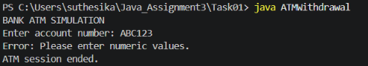
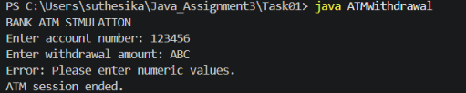
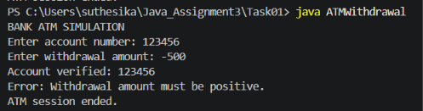
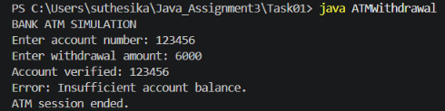
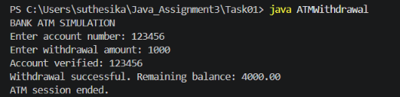
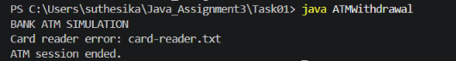
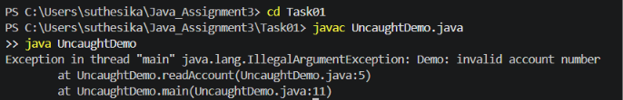
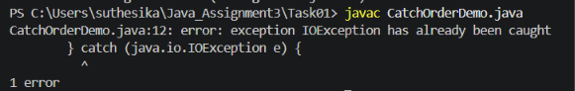
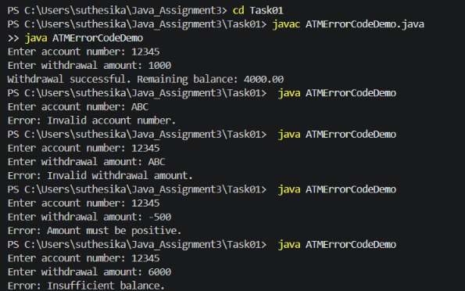
TASK 02 – USER-DEFINED EXCEPTIONS AND PROPAGATION IN AN ONLINE EXAMINATION PORTAL
1. AIM
To design and implement user-defined exceptions in an Online Examination Portal using Java. The program demonstrates exception hierarchy, checked and unchecked exceptions, exception propagation across different application layers, and exception chaining while preserving the original cause.
2. PROBLEM DESCRIPTION
An Online Examination Portal must reject a student's submission under three conditions:
- The examination window has closed.
- The student is not registered for the course.
- The submitted answer file exceeds the permitted size of 500 KB.
These conditions are checked at different application layers: controller, service, and storage. User-defined exceptions provide meaningful error messages and help handle failures properly.
3. PROGRAM IMPLEMENTATION
The task was implemented using three Java programs:
- StorageDemo.java: Completes the given TODO1 by wrapping an IOException inside a SubmissionStorageException.
- PortalExceptionDemo.java: Demonstrates the three failure scenarios and exception propagation through the controller, service, and storage layers.
- ChainingDemo.java: Demonstrates exception chaining using getCause(), displays the complete chained stack trace, and shows the result when the original cause is not preserved.
3.1 Exception Hierarchy
The following exception hierarchy was designed:
- Exception – Java's built-in exception superclass.
- ExamPortalException – Parent class for the portal's checked exceptions.
- ExamWindowClosedException – Raised when the examination window is closed.
- StudentNotRegisteredException – Raised when the student is not registered.
- SubmissionStorageException – Raised when the answer file cannot be stored.
- InvalidSubmissionRequestException – An unchecked exception extending RuntimeException, used for invalid input such as a negative file size.
3.2 Classification of Exceptions
Exception | Type | Reason
ExamWindowClosedException | Checked | The application must handle an expired examination window.
StudentNotRegisteredException | Checked | Registration must be verified before accepting a submission.
SubmissionStorageException | Checked | Storage failures must be handled by the application.
InvalidSubmissionRequestException | Unchecked | Invalid input is rejected at runtime and does not require mandatory compiler handling.

Checked exceptions extend Exception, whereas unchecked exceptions extend RuntimeException.
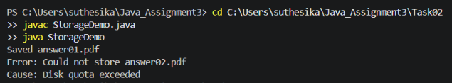
4. STUDENT A – EXCEPTION HIERARCHY AND PROPAGATION DESIGN
4.1 Class Diagram
The exception hierarchy is represented as follows:
Exception
↓
ExamPortalException
├── ExamWindowClosedException
├── StudentNotRegisteredException
└── SubmissionStorageException
RuntimeException
└── InvalidSubmissionRequestException
The three portal-specific business and storage exceptions are checked exceptions. InvalidSubmissionRequestException is an unchecked exception.
4.2 Exception Propagation Across Layers
The application contains three main layers:
- Storage Layer: Checks the answer file size. If the file exceeds 500 KB, an IOException is generated. It is caught and wrapped inside SubmissionStorageException.
- Service Layer: Calls the storage method and propagates the declared exception to the controller.
- Controller Layer: Catches the custom exception and displays a meaningful error message to the student.
Propagation Path:
Storage Layer
↓
IOException occurs
↓
Wrapped as SubmissionStorageException
↓
Service Layer propagates the exception
↓
Controller Layer catches the exception
↓
Student receives a meaningful error message.

4.3 Final Exception Handling
The controller is responsible for handling the exception and displaying a student-friendly message.
Example:
Student message: Could not store answer03.pdf
Original technical cause: Disk quota exceeded
This approach prevents technical storage details from being directly exposed as the main student-facing error message.
5. STUDENT B – FAILURE SCENARIOS AND EXCEPTION CHAINING EVIDENCE
5.1 Failure Scenarios
Three failure scenarios were implemented and tested.
Scenario 1 – Examination Window Closed
When the examination window is closed, the system throws ExamWindowClosedException and rejects the submission.
Observed message:
Student message: The examination window is closed.
Scenario 2 – Student Not Registered
When the student is not registered for the course, the system throws StudentNotRegisteredException and rejects the submission.
Observed message:
Student message: Student is not registered for this course.
Scenario 3 – File Exceeds the Size Limit
When the submitted answer file exceeds 500 KB, the storage layer generates an IOException. The exception is wrapped inside SubmissionStorageException.
Observed messages:
Student message: Could not store answer03.pdf
Original cause: Disk quota exceeded
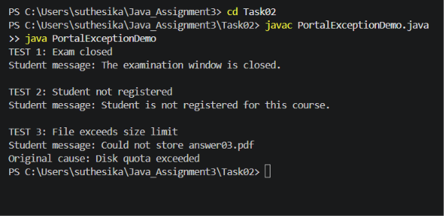
5.2 Exception Chaining Using getCause()
Exception chaining preserves the original exception when a new custom exception is created.
The following statement was used:
throw new SubmissionStorageException("Could not store " + fileName, e);
Here, e represents the original IOException.
The getCause() method retrieves the original exception.
Observed output:
TEST 1: Exception with original cause
Error: Could not store answer.pdf
Cause: Disk quota exceeded

Full chained stack trace:
ChainedStorageException: Could not store answer.pdf
at ChainingDemo.main(ChainingDemo.java:26)
Caused by: java.io.IOException: Disk quota exceeded
at ChainingDemo.main(ChainingDemo.java:24)

TEST 2: Exception without original cause
Error: Could not store answer.pdf
Cause: null
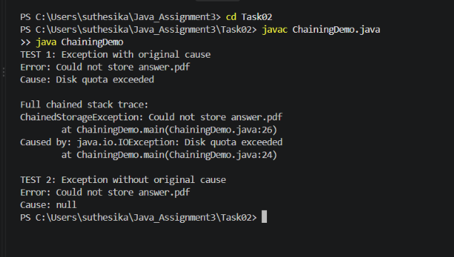
5.3 Information Lost Without Exception Chaining
If the original IOException is not passed to the custom exception constructor, the cause becomes null.
The original error message, Disk quota exceeded, and its original stack-trace details are no longer available through the custom exception's cause chain.
Therefore, exception chaining is useful for debugging and identifying the actual source of a failure.
5.4 Test Table
Test No. | Test Scenario | Expected Behaviour | Observed Behaviour | Status
1 | Save a file of 120 KB | File should be saved | Saved successfully | Passed
2 | Save a file of 800 KB | Storage exception should occur | SubmissionStorageException generated | Passed
3 | Examination window closed | Submission should be rejected | ExamWindowClosedException handled | Passed
4 | Student not registered | Submission should be rejected | StudentNotRegisteredException handled | Passed
5 | Exception with original cause | Original IOException should be available | getCause() returned Disk quota exceeded | Passed
6 | Exception without original cause | Cause should be unavailable | getCause() returned null | Passed

6. JOINT CONCLUSION
Using a meaningful SubmissionStorageException is better than allowing a raw IOException to travel unchanged to the user interface.
A custom exception provides a meaningful error message that is related to the application's business requirements. It also separates internal storage details from the user interface.
Exception chaining preserves the original IOException as the cause, allowing developers to identify and debug the actual technical failure. Therefore, user-defined exceptions improve readability, maintainability, and error handling in the Online Examination Portal.
7. ALTERNATIVE CONCEPT AND COMPLEXITY ANALYSIS
7.1 Checked Exceptions vs Unchecked Exceptions
In this implementation, custom exceptions extend Exception and are therefore checked exceptions.
If these exceptions were changed to extend RuntimeException:
- The methods would not be required to declare them using the throws keyword.
- The compiler would not force calling methods to catch or declare them.
- The calling code could handle them using try-catch if required.
- Error handling would become optional for the caller.
Checked exceptions are useful for expected application failures that callers should handle. Unchecked exceptions are more suitable for programming errors or invalid operations.
7.2 Time Complexity of Stack Trace Capture
Capturing a stack trace requires Java to examine the current call stack.
If the call-stack depth is d, the approximate time complexity is O(d).
7.3 Space Complexity of Stack Trace Capture
The stack trace stores information about the methods and locations involved in the exception. Its approximate space complexity is O(d), where d is the call-stack depth.
7.4 Memory Cost of Exception Chaining
Exception chaining stores a reference to the original exception using the cause field.
The original exception and its stack trace remain reachable through this reference. Therefore, memory usage increases according to the number of exceptions and the size of their stack traces in the cause chain.
Exception chaining improves debugging but retains additional exception information in memory.
8. RESULT
The Online Examination Portal exception-handling program was successfully implemented and executed. The three failure scenarios were tested, custom checked and unchecked exceptions were demonstrated, exception propagation was implemented across application layers, and exception chaining was verified using getCause() and the full stack trace.
All the executed test cases produced the expected behaviour.

TASK 03 – RESOURCE SAFETY, DEBUGGING AND ROBUST CODE
1. Aim
To understand resource management in Java by comparing manual resource closing using try-catch-finally with automatic resource management using try-with-resources. The program generates a daily sales report by reading store files and writing the results into a report file. It also demonstrates resource leaks and suppressed exceptions.
2. Program Description
The program uses three valid store input files and one file containing invalid data.
- store1.txt – Store A, 1200
- store2.txt – Store B, 1500
- store3.txt – Store C, 1800
- store-fail.txt – Contains an invalid sales value (INVALID).
The program implements two versions:
- Manual resource management: Resources are opened and closed explicitly.
- Try-with-resources: Java automatically closes resources when the try block finishes, including when an exception occurs.
The program also tracks open readers and writers and demonstrates suppressed exceptions.
3. Student A – Debugging and Resource Leak Analysis
3.1 Identifying the Resource Leak
In the manual version, the input reader is closed only after the file has been read successfully.
When the program reads the invalid value INVALID, Integer.parseInt() throws a NumberFormatException. Because the exception occurs before reader.close(), the reader remains open.
The writer is closed in the finally block, but the reader is not closed.
3.2 Failure Details and Logging
The program identifies the file that causes the error and displays the exception message.
Observed output:
Manual version failed at: store-fail.txt
Error: For input string: "INVALID"
Open readers: 1
Open writers: 0
Total open resources: 1
This confirms that one reader remains open after the failure. The program then uses a cleanup method to close the leaked reader.
Debugging note: The program's output and resource counters were used to identify the failure. A VS Code breakpoint screenshot was not captured.
3.3 Resource Count
The program uses custom counters to track open readers and writers. These are application-level resource counts, not direct operating-system file descriptor measurements.
4. Student B – Resource Management and Exception Handling
4.1 Resources Used
The program uses the following resources:
- TrackedReader for reading each store input file.
- TrackedWriter for writing the daily sales report.
In the manual version, the reader is closed only after successful reading. If an exception occurs before the close statement, the reader may remain open.
In the try-with-resources version, both reader and writer are declared inside try-with-resources statements. Java automatically invokes their close() methods when control leaves the resource scope.
4.2 Closing Order
When multiple resources are declared in a single try-with-resources statement, Java closes them in reverse order of declaration.
In this program, the reader is inside the nested resource scope. Therefore, the reader closes first when its scope ends, followed by the outer writer.
4.3 Suppressed Exception
The program demonstrates a situation where the main report-processing operation throws an IOException, and the resource's close() method also throws an IOException.
The main exception remains the primary exception. The exception thrown during closing is stored as a suppressed exception.
Observed output:
TEST 5: SUPPRESSED EXCEPTION
Main exception: Report processing failed
Suppressed exception: Resource close failed
The getSuppressed() method is used to retrieve the suppressed exception.
5. Test Cases and Results
Test | Description | Expected result | Actual result
1 | Manual version with valid files | Report generated and resources closed | Passed
2 | Try-with-resources with valid files | Report generated and resources closed | Passed
3 | Manual version with invalid data | Error displayed and reader leak detected | Passed
4 | Try-with-resources with invalid data | Error displayed and resources automatically closed | Passed
5 | Suppressed exception demonstration | Main and suppressed exceptions displayed | Passed

Important Observations
- The manual version generated the report successfully for valid input.
- The try-with-resources version also generated the report successfully.
- The manual version left one reader open when invalid data caused an exception.
- The try-with-resources version closed all tracked resources even when an exception occurred.
- The suppressed exception was successfully displayed.
6. Joint Discussion – Limitations of Try-with-Resources
Try-with-resources provides automatic resource closing, but it does not solve every problem in a report-generation system.
It does not automatically:
- Validate incorrect input data.
- Recover from missing or corrupted files.
- Retry failed operations.
- Guarantee that the report is complete or correct.
- Guarantee successful closing if a resource's close() method itself fails.
Therefore, input validation, exception handling, logging, and recovery mechanisms are still necessary.
7. Alternative Approach and Complexity Analysis
7.1 Alternative Approach
An alternative is to use explicit resource closing inside a finally block. The reader can be declared before the try block and closed in the finally block, ensuring that it is closed whether the file succeeds or fails.
If resources are not closed properly, the program may consume too many file handles and eventually encounter a resource exhaustion error.
7.2 Time Complexity
Let S represent the total amount of input data processed across all files.
- Reading and processing the files takes O(S) time.
- Writing the report also takes time proportional to the output size.
- Therefore, the overall processing time is linear in the total input and output size.
7.3 Space Complexity and Resource Usage
The program processes the files line by line, so it does not need to store all file contents in memory.
- Extra processing memory is O(1), excluding output storage and fixed-size buffers.
- The try-with-resources version normally keeps one reader and one writer open at a time, giving a maximum of two simultaneously open resources.
- In the tested manual failure, one reader remained open after the method finished, while the writer was closed in the finally block.
- If a program continues processing files without closing failed readers, leaked resources can accumulate as O(f), where f is the number of affected files.
8. Conclusion
This task demonstrated the importance of proper resource management in Java. Manual resource closing can cause resource leaks when an exception occurs before the close statement. Try-with-resources provides safer automatic resource management and closes resources even when exceptions occur.
The program successfully generated reports, detected invalid input, tracked open resources, and demonstrated suppressed exceptions. Therefore, try-with-resources is the recommended approach for managing files and other closeable resources in Java.

TASK 04 – THREAD CREATION AND THE THREAD LIFE CYCLE
1. Aim
To understand Java multithreading by creating scanner stations using the Thread class and Runnable interface. The experiment demonstrates thread creation, execution, sleep(), join(), isAlive(), thread priorities and daemon threads.
2. Program Description
The program simulates four answer-scanning stations. Each station processes a batch of answer scripts.
Station | Scripts scanned
Station 1 | 10
Station 2 | 12
Station 3 | 8
Station 4 | 15
Total | 45

The program implements the stations in two ways:
- By extending the Thread class.
- By implementing the Runnable interface.
An AtomicInteger is used to update the shared total safely when multiple threads are running.
3. Student A – Thread Design and Life Cycle
3.1 Extending Thread vs Implementing Runnable
Extending Thread: A class extends Thread and overrides the run() method. The object itself represents a thread.
Implementing Runnable: A class implements Runnable and defines the run() method. The Runnable object is passed to a Thread object.
Extending Thread | Implementing Runnable
Extends the Thread class | Implements the Runnable interface
Cannot extend another class | Can extend another class
Combines task and thread | Separates task from thread
Suitable for simple thread-specific classes | More flexible and reusable

Implementing Runnable is generally preferred when the task should be separated from thread management.
3.2 Thread Life Cycle
Java defines the following official thread states:
- NEW – Thread object is created but not started.
- RUNNABLE – Thread is ready or executing.
- BLOCKED – Thread is waiting to acquire a monitor lock.
- WAITING – Thread waits indefinitely for another thread's action.
- TIMED_WAITING – Thread waits for a specified period.
- TERMINATED – Thread has completed execution.
Life-cycle diagram:
NEW → RUNNABLE → TIMED_WAITING → RUNNABLE → TERMINATED
In this experiment, sleep() places a worker thread in TIMED_WAITING. The main thread enters WAITING when it calls join() and waits for a worker to finish.
Java includes execution and ready-to-run threads together in the RUNNABLE state.

3.3 Difference Between run() and start()
Calling run() directly executes the method on the current thread. It does not create a new thread.
Calling start() creates a new thread, and the JVM executes its run() method on that thread.
The RunVsStartDemo output showed:
- Direct run(): Station 1 is running on thread: main
- start(): Station 2 is running on thread: Thread-0
This proves that start() creates a separate execution thread, while a direct run() call does not.
3.4 Use of join() and isAlive()
The start() method begins thread execution.
The isAlive() method checks whether a thread has started and has not yet terminated.
The join() method makes the calling thread wait until the specified worker thread finishes.
The program uses join() on all four worker threads before printing the final total. This ensures that all scanning operations are completed before the result is displayed.
4. Student B – Thread Experiments
4.1 Ten Execution Runs
The program was executed ten times using both Thread and Runnable implementations.
The starting order varied between runs because the operating system and JVM scheduler determine when threads execute.
The finishing order was consistently:
Station 1 → Station 2 → Station 3 → Station 4.
This happened because each station had a different sleep duration. The experiment demonstrates that thread scheduling is not fully predictable, and the finishing order in this particular program was also influenced by the assigned delays.
All ten runs produced the correct final total of 45 scripts for both implementations.

4.2 Thread Priority Experiment
The program assigned these priorities:
Station | Priority
Station 1 | 1 (MIN_PRIORITY)
Station 2 | 5 (NORM_PRIORITY)
Station 3 | 10 (MAX_PRIORITY)
Station 4 | 5 (NORM_PRIORITY)

The experiment was repeated five times.
The observed finishing order remained Station 1, Station 2, Station 3 and Station 4. The starting order could vary.
Thread priority is only a scheduling hint. It does not guarantee that a higher-priority thread will always execute or finish first.
4.3 Daemon Thread Experiment
One scanner station was converted into a daemon thread using setDaemon(true).
The output showed:
- Daemon station started.
- Is daemon: true.
- Main thread is ending.
The daemon station did not print its completion message. This happened because the JVM can exit when only daemon threads remain after all user threads have finished.
The experiment was repeated five times with the same observed result.

5. Test Results
Test | Expected result | Observed result
Thread implementation | All stations complete | Passed
Runnable implementation | All stations complete | Passed
Direct run() | Executes on main thread | Passed
start() | Executes on separate thread | Passed
join() | Waits for worker completion | Passed
isAlive() | Reports active thread | Passed
Ten execution runs | Total is 45 each time | Passed
Priority experiment | Priorities are assigned | Passed
Daemon experiment | JVM exits without waiting for daemon | Passed

6. Joint Discussion – Nondeterministic Execution
When multiple threads run concurrently, their starting order may change between executions. The JVM and operating system scheduler control thread execution.
Therefore, a program should not depend on a particular thread finishing first.
In this experiment, AtomicInteger safely updates the shared script count. The join() method ensures that all stations finish before the final total is printed.
The final result remains 45 even when the starting order changes.
7. Alternative Approach – ExecutorService
Instead of creating and managing individual Thread objects, the program can use ExecutorService with a fixed thread pool.
A fixed thread pool reuses a limited number of worker threads to execute multiple scanning tasks.
For n scanning tasks and p worker threads, the work can be distributed across approximately ceil(n/p) batches when task durations are similar.
Complexity comparison:
Approach | Time complexity | Thread stack memory
One thread per task | O(n) total work | O(n × stack size)
Fixed thread pool | O(n) total work | O(p × stack size)

ExecutorService is generally more suitable for a large number of tasks because it controls the number of active worker threads and reuses them.
8. Conclusion
The experiment demonstrated Java thread creation using both Thread and Runnable. It verified run(), start(), sleep(), join() and isAlive(), and explored thread priorities and daemon threads.
The ten-run experiment confirmed that thread starting order can vary. AtomicInteger and join() helped maintain a correct final result of 45 scanned scripts.
ExecutorService provides a more manageable approach when handling a large number of concurrent scanning tasks.

